Database Management System LAB
Spring Semester 2024-25
Lab Assignment 4
Name – Soham Chakraborty
Roll No – 22CS02002

Table Creation

Foreign Keys will be added later on after creating all tables

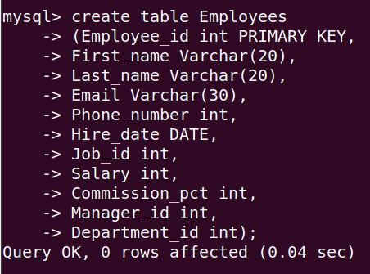

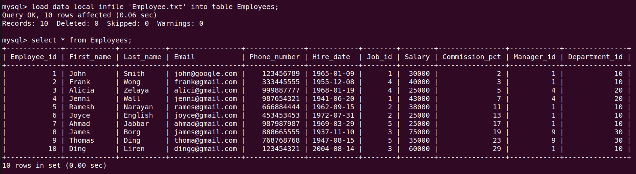
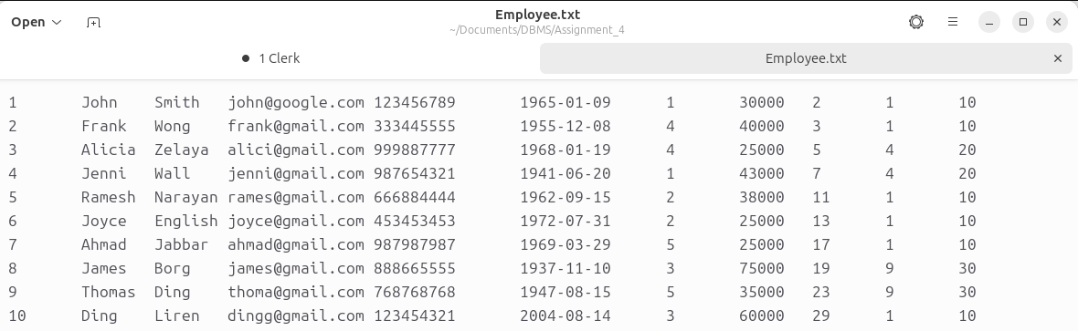

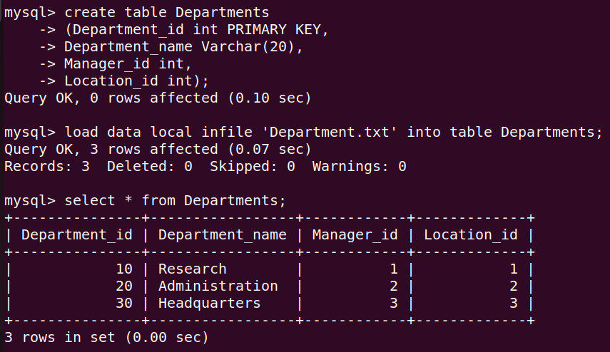
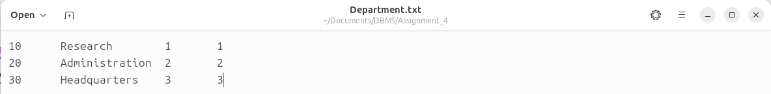

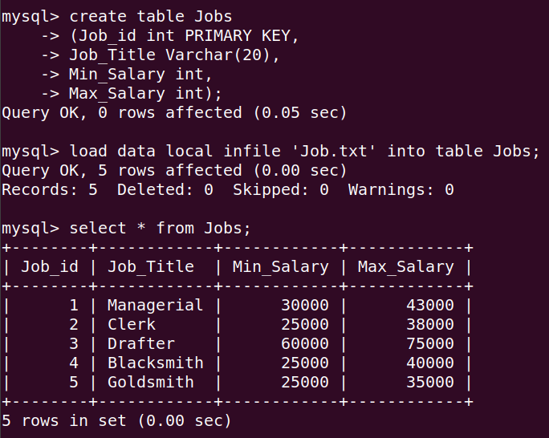
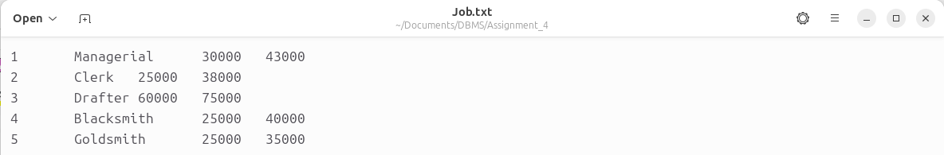

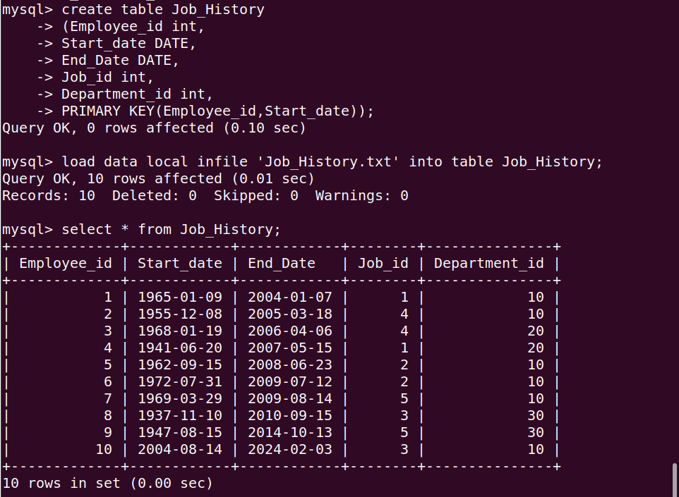
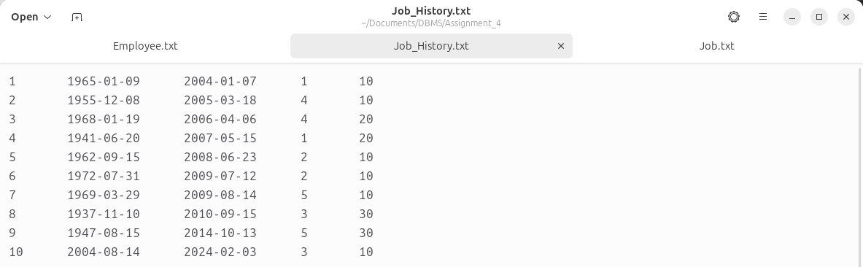

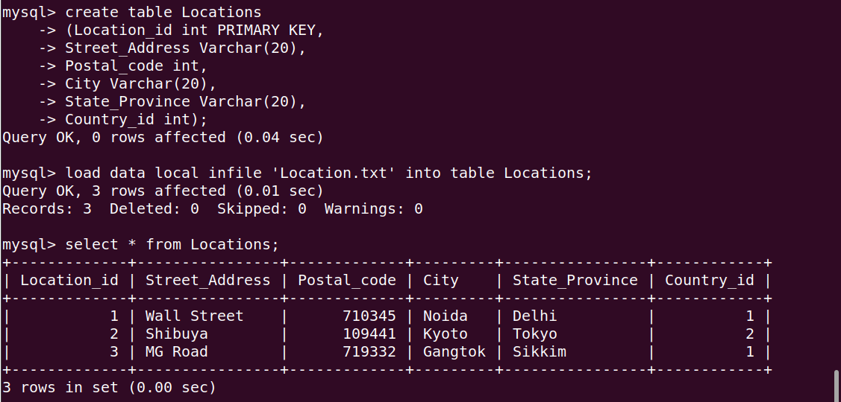
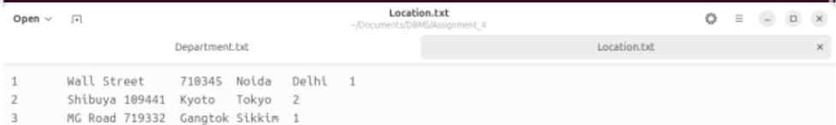

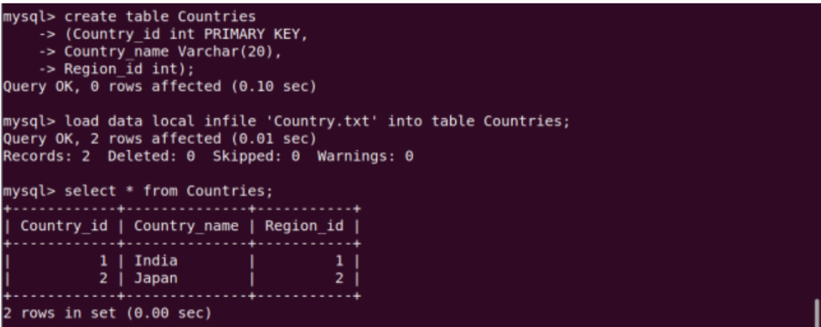

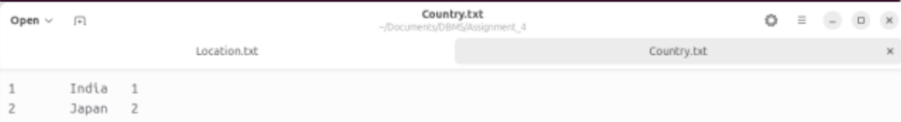

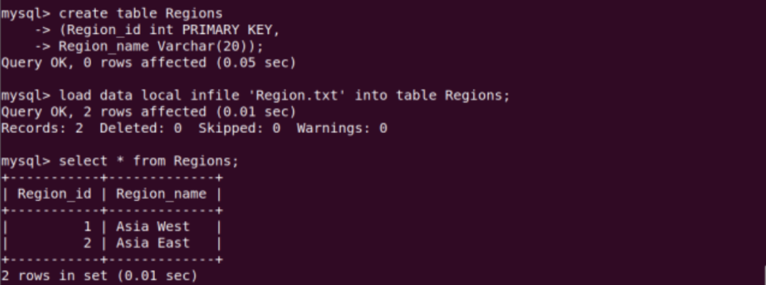

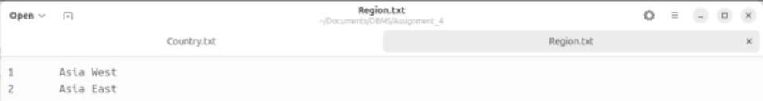

Adding Foreign Key Constraints

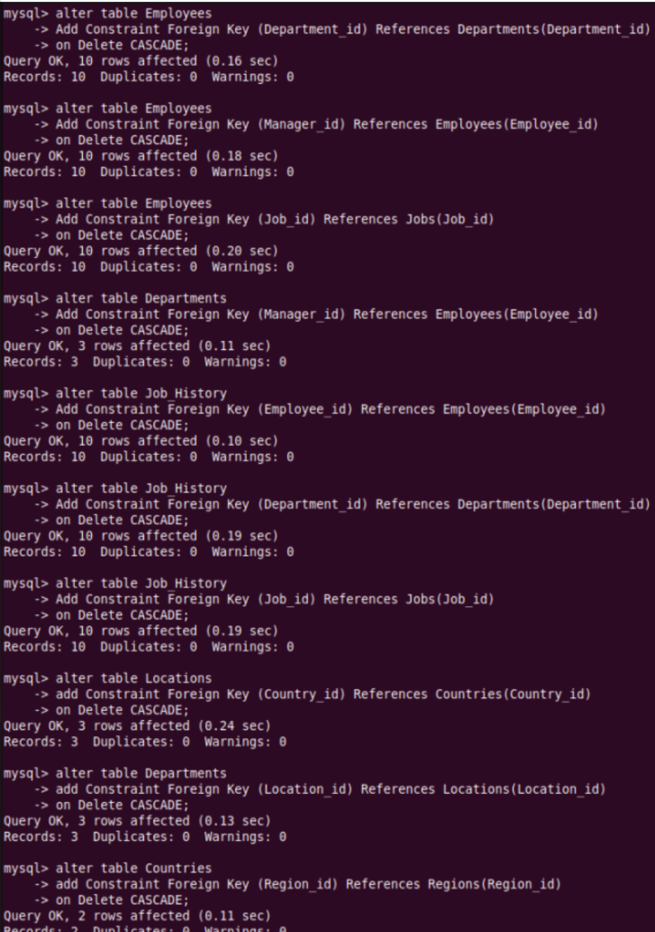

Ans – 1)
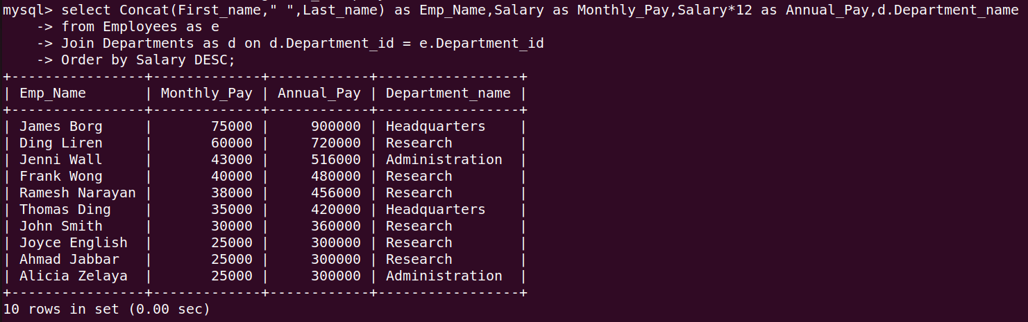
Ans – 2)
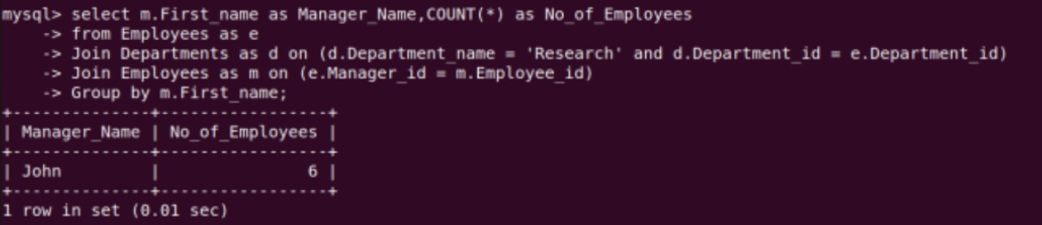

Ans – 3)
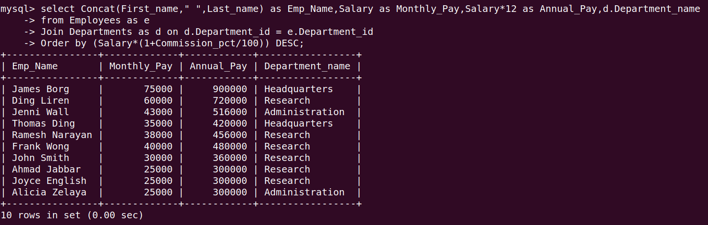

Ans – 4)

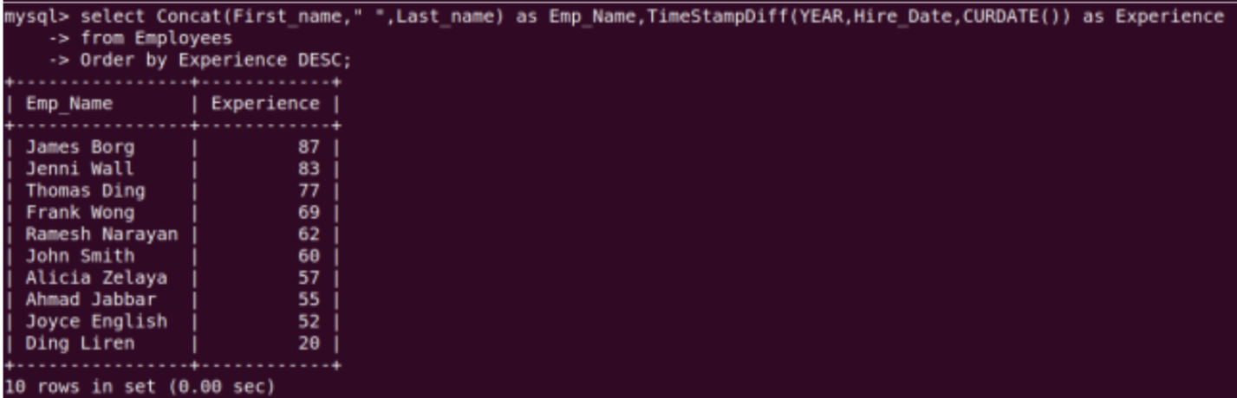

Ans – 5) Note that here There is no DeptNo = 90 present in this table
Alternate query for DeptNo = 30 (as it is present in table)
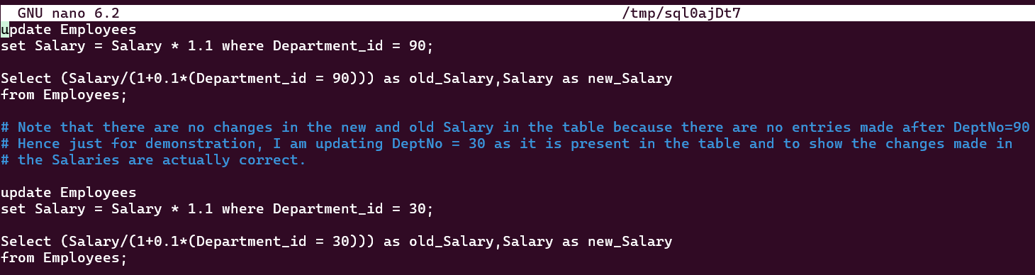

Ans – 6)

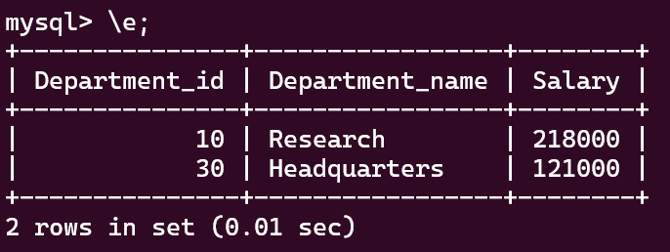

Ans – 7)

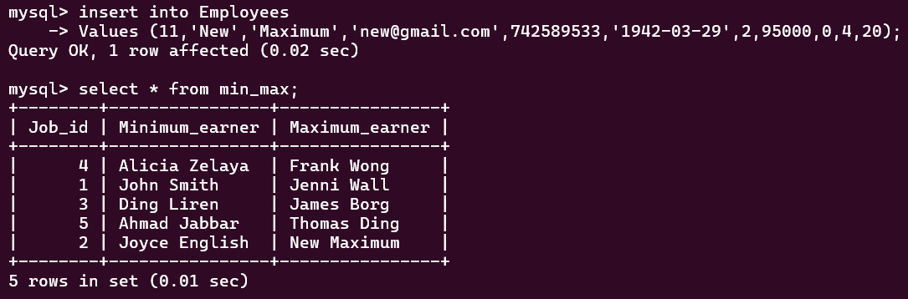

Employee ‘New Maximum’ is now the maximum earner for Job 2 and clearly the view was updated.

Ans – 8)
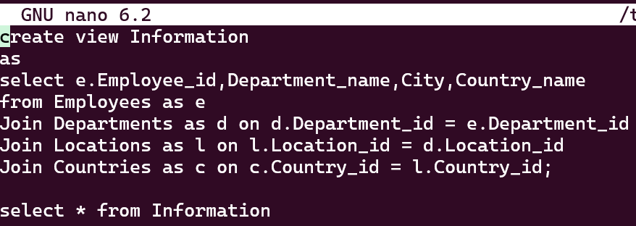

Ans – 9)
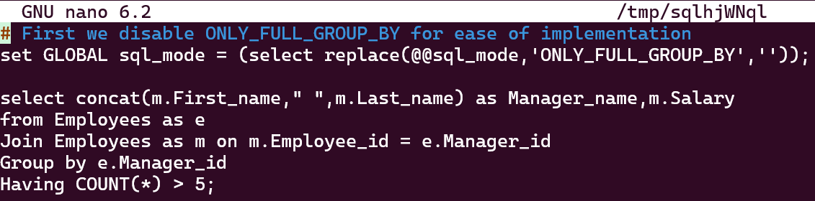

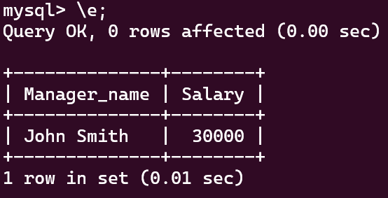

Ans – 10)
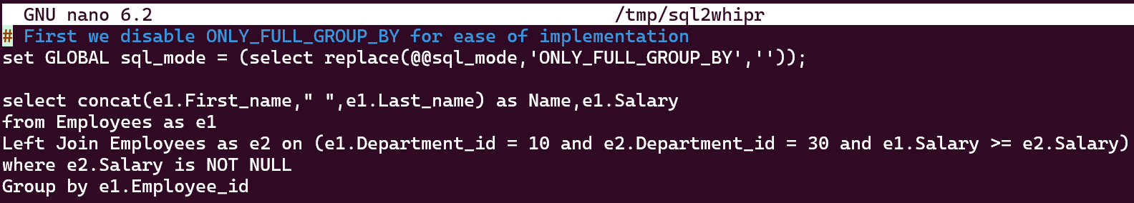

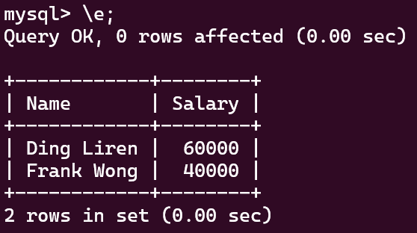

Ans – 11)
